- generate a project in C++ raylib to display the functionality of a linked list

- add functionality to this code to allow for inserting nodes in the middle of the list [code block]

- asked for improvements, asked to add said improvements to code block
Encountered error
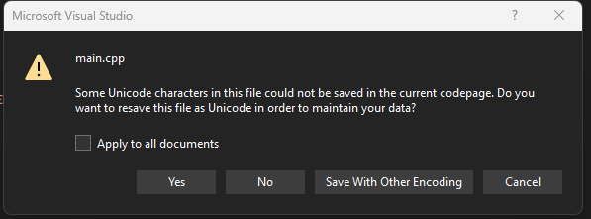
Still compiled

- add functionality into this code to allow the user to enter a value they want, and change the arrow keys for on screen buttons with the user inputting a specific index to input before and after
- add an animation to this code when a new node is added to the list
- insert those animation changes into the code block directly -> failed, code stuck in loop, revert to old code, manually add changes

